I’m thinking about…

I see…

I hear…

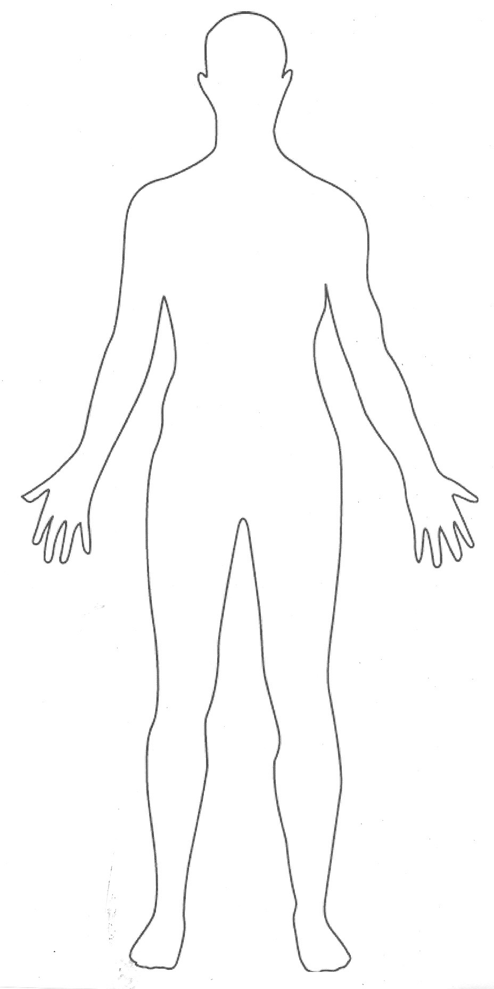

I hunger for…

I stand on the principles of…

I embrace the ideas of…

I reject the ideas of…

The thing that is most important to me is…

I am carrying the burden of…

I say…