The House of Cardia

The House of Cardia is a strange, isolated house. Most of the people who live there are old and have known each other for a long time. The housemates do not trust each other and are constantly trying to be better and more powerful than the rest of the people in the house. The house is surrounded by a beautiful, massive garden. Some members of the hoes have no garden, while others have lots. The people in the house want as much of the garden as they can get their hands on, and will do anything they can to get some of it.

Think carefully about the descriptions of each of the people in the house. As you read, try to work out who in the house may fall out with somebody else and what they may fall out about.

Brian
Brian is very snobbish and he looks down on all of his other housemates. He is big and still quite strong, but he is middle-aged. He lives in his own apartment on the estate and has little to do with the other members of the house. Brian owns most of the garden and doesn’t want to share it would anyone – which is why he is so concerned about the sun-lounger (lawn chair) that Geri has purchased…

Frances
Frances used to be the most important person in the house, but she has had problems recently: some time ago, Geri beat Frances up in a fight, and stole her walk-in closet. As a result, France hates Geri, and wants her closet back. On the bright side, Frances still owns a large part of the garden.

Geri
Geri was once weak and used to be bullied by Frances. Most recently, Geri has been working out and has become very fit and strong. She is very jealous of Frances and Brian because she does not own much of the garden. Geri is determined to get more of the garden so that she can sunbathe… even if that means that she will put up fences around Brian and Frances’ part. Geri is very angry that Brian is refusing to allow her access to the garden, and has bought a sun-lounger anyway.

Austin
Austin was once big and strong but now he is old and weak. He is very proud and wants to extend hs already large room. Encouraged by his close relative Geri, he recently moved some of his things into young Boswell’s room, much to the alarm of Sebastian, who lives in the room next door.

Russell
Russell is the biggest person in the house and therefore had the biggest room. Russell is quite unfit, so he is slow whenever he decides to do anything. He is Sebastian’s uncle, and therefore hates Austin.

Otto
Otto is the “sick man” of the house. He is very, very old and he finds it extremely difficult to look after his room and his part of the garden. Otto knows that both Austin and Russell want his room and his garden and swaps sides whenever arguments between Austin and Russell break out.

Sebastian
Sebastian, like Boswell, is a teenage rebel. Both boys were brought up by Otto, but they lost respect for him and renovated his house to provide them with fresh rooms. They had talked about knocking out the wall between their two rooms together and creating a “bachelor pad,” but then Austin went through the court system to adopt Boswell. Sebastian is worried that Austin will try to adopt him next.

Bella
Bella is a child – the youngest and weakest member of the house. The child looks to Brian for protection from her loud and scary neighbors. She always tries to stay out of arguments whenever they occur.

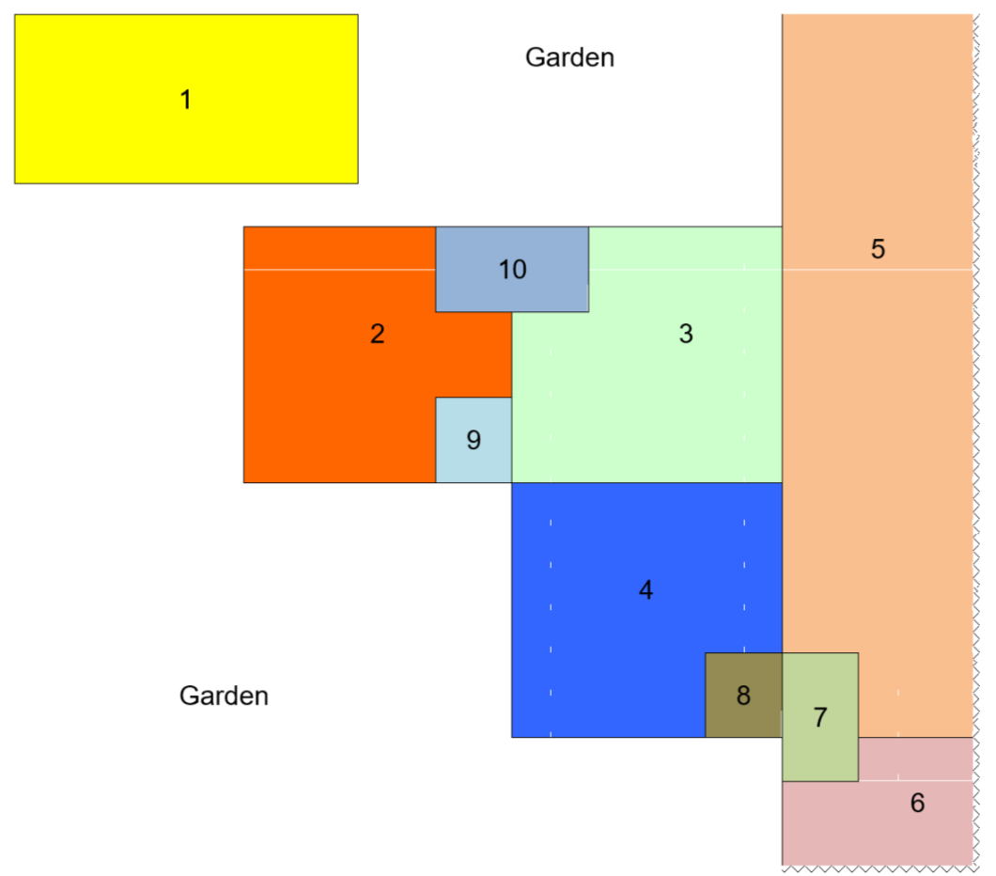
Key:
- Brian
- Frances
- Geri
- Austin
- Russell
- Otto
- Sebastian
- Boswell
- Walk-in closet
- Bella

Processing questions:
*you will fill out the last column – what this really represents – after we discuss it as a class!

Who hates whom? | Why do they hate each other? | What does this really represent?

What are the housemates likely to argue about? | Who argues over this? | What does this really represent?
Walk-in wardrobe

Bella’s room

Garden

If a big argument were to break out in the house, and the people in the house were to form into two groups, who would be in each group?
Group 1: | Group 2:

If a fight did break out between the two groups, who do you think would win? Why?
I think group ___ would win, because

