Station 1: Poll Tax

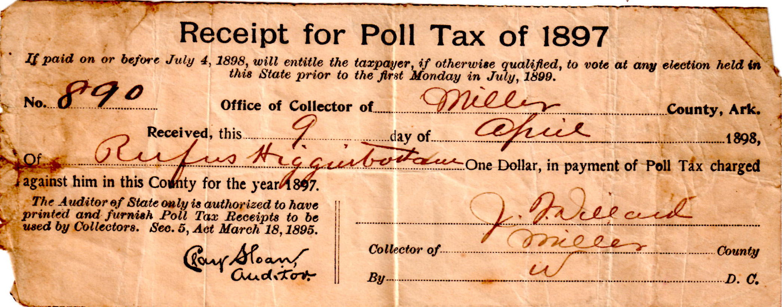

“The estimates of black rural per capita labor [annual] income are $38.11 in the cotton-growing regions and $36.93 in the whole South.”
- Kenneth Ng and Nancy Virts, “The Black-White Income Gap in 1880”, Agricultural History, Vol. 67, No. 1 (Winter, 1993)

For comparison: “The average [white] teacher during the decade earned less than $72 a year -- and you only commanded this salary if you were male. Women educators during the period had it worse, earning just $54.50 annually.”

Station 2: Louisiana State Constitution (1898)

Article 197
Sec. 4. If he be not able to read and write, as provided by Section three . . . then he shall be entitled to register and vote if he shall, at the time he offers to register, be the bona fide owner of property assessed to him in this State at a valuation of not less than three hundred dollars . . . and on which, if such property be personal only, all taxes due shall have been paid. . . .

Sec. 5. No male person who was on January 1st, 1867, or at any date prior thereto, entitled to vote under the Constitution or statutes of any State of the United States, wherein he then resided, and no son or grandson of any such person not less than twenty—one years of age at the date of the adoption of this Constitution, and no male person of foreign birth, who was naturalized prior to the first day of January, 1898, shall be denied the right to register and vote in this State by reason of his failure to possess the educational or property qualifications prescribed by this Constitution; provided, he shall have resided in this State for five years next preceding the date at which he shall apply for registration, and shall have registered in accordance with the terms of this article prior to September 1, 1898, and no person shall be entitled to register under this section after said date. . . .

Station 3: Literacy Tests

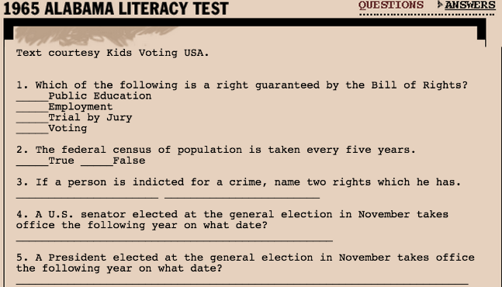

Station 4: Plessy v. Ferguson (1896)

The legal case began when Homer Plessy, a man who was ⅞ white and ⅛ African American, was arrested for sitting in the white-only train car in Louisiana. Supported by a committee of black and mixed-race professionals and lawyers, they sued until the case reached the Supreme Court.

The Supreme Court ruled 7-0 that Louisiana’s state law that allowed for “equal but separate accommodations for the white and colored races” was constitutional.

They argued:
“We consider the underlying fallacy (mistaken belief) of the plaintiff’s (Plessy’s) argument to consist in the assumption that the enforced separation of the two races stamps the colored race with a badge of inferiority. If this be so, it is not by reason of anything found in the act, but solely because the colored race chooses to put that construction upon it…

The argument also assumes that social prejudice may be overcome by legislation, and that equal rights cannot be secured except by an enforced commingling of the two races…

If the civil and political rights of both races be equal, one cannot be inferior to the other civilly or politically. If one race be inferior to the other socially, the Constitution of the United States cannot put them upon the same plane.”

- Majority Opinion delivered by Justice Henry Brown of Michigan, 1896

Station 5: Texas laws (just a few)

1866: Educational Segregation: All taxes paid by blacks to go to maintaining African schools. Duty of the legislature to "encourage colored schools."

1891: Railroad Segregation: Separate coaches for white and Negro passengers to be equal in all points of comfort and convenience. Designed by signage posted in a conspicuous place in each compartment. Trains allowed to carry chair cars or sleeping cars for the exclusive use of either race.
- Penalty: Conductors who failed to enforce law faced misdemeanor charge punishable by a fine from $5 to $25. ($25 in 1890 is equivalent to $700 today)
- The railroad company could be fined from $100 to $1,000 for each trip. ($1,000 in 1890 is equivalent to $28,000 today)
- Passengers who refused to sit in designated areas faced fines from $5 to $25.

1915: Miscegenation: The penalty for intermarriage is imprisonment in the penitentiary from two to five years.
- Updated later to be more specific: Unlawful for person of Caucasian blood to marry person of African blood. Penalty: Two to five years' imprisonment.

1922: White Primaries: "...in no event shall a Negro be eligible to participate in a Democratic party primary election held in the State of Texas. "
- Overturned in 1927 by U.S. Supreme Court in Nixon v. Herndon.
- Texas changed the law delegating responsibility to each political party to make its own decision about who could participate in its primaries. The Supreme Court upheld this decision since it wasn’t the government doing the discriminating.

1925: Educational Segregation: Required racially segregated schools.

Exploring Black Codes: Stations Worksheet
Station 1: Poll Tax
- How much was the Poll Tax in Arkansas, according to the image?

- Although the poll tax was technically applied to all voters, whom did it impact the most? How do you know this?

- What was the purpose of creating a poll tax?

Station 2: Louisiana State Constitution
- According to Section 4, if someone cannot read or write, how else can they qualify to vote?

- Section 5 is often called a “Grandfather Clause.” What did this clause say about people whose grandfather had voted?

- How does the Grandfather Clause discriminate against African Americans?

Station 3: Literacy Tests *Complete the literacy test on your own in the space below.
1. _____________________________
2. _____________________________
3. _____________________________
4. _____________________________
5. _____________________________

- How did you feel when you were taking the test?

- What was one question that you might describe as “unfair”? Why?

- How did this further disenfranchise* (*deprive someone of a right or privilege) African-Americans in the South?
Station 4: Plessy v. Ferguson
- In the majority decision, who did the Supreme Court blame for the “inferiority” of “colored” facilities?

- Translate the last line of the decision into your own words:
“If one race be inferior to the other socially, the Constitution of the United States cannot put them upon the same plane.”

Station 5: Texas laws
- What are at least two laws that stuck out to you? What were your reactions when you read them?

