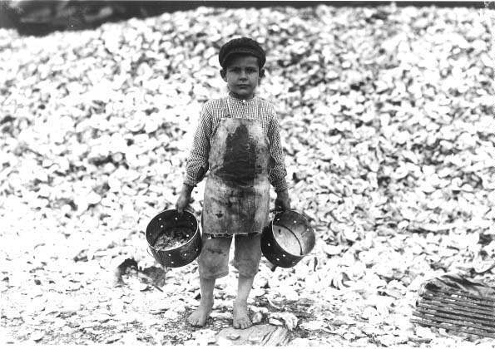
Photo: Shrimp and Oyster Worker, 1911

In his report "Child Labor in the Cotton Mills of Mississippi" (1911), Hines (the photographer) noted that he had taken pictures of "most of the youngest workers," as well as older workers under sixteen who worked 60 hours a week instead of 63 1/2, "reduced hours" compared to adults. Hine's colleague, Edward F. Brown, in his report "Child Labor in the Gulf Coast" (1913), identified 26 children from ages 7 to 14 (including, for example, six 10-year-olds and five 12-year-olds) working at one oyster factory at 4:45 a.m.

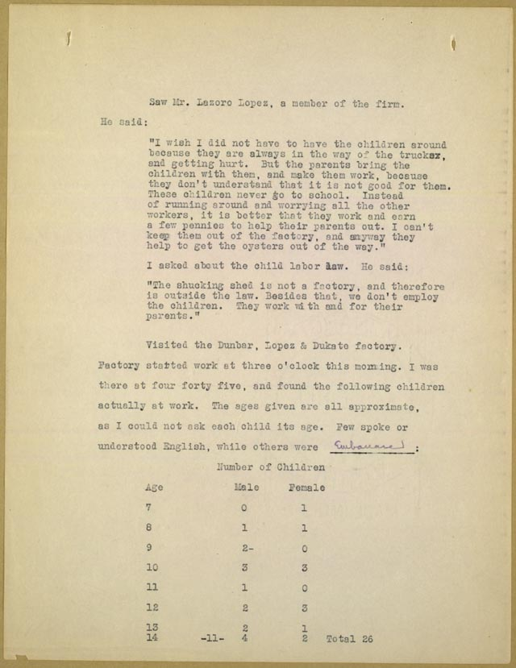

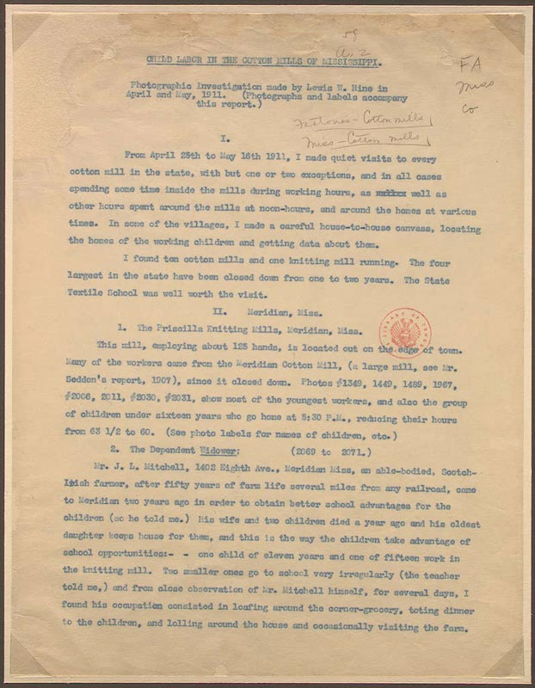

Photo: Workers at a Glass Factory

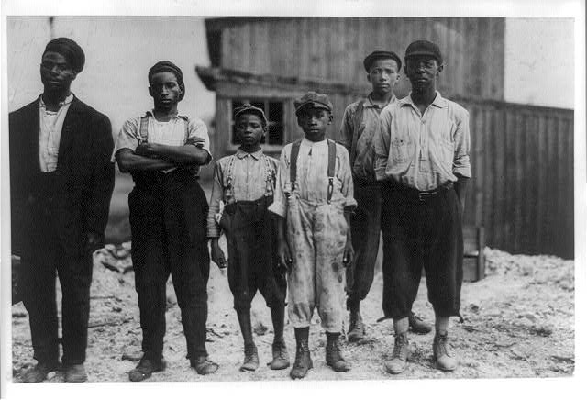

Portrait of Alva Vanderbilt, c. 1885
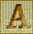
"Why, there are only about 400 people in fashionable New York society," wrote Caroline Astor in an 1888 letter to the New York Tribune. "If you go outside that number you strike people who are not at ease in a ballroom or else make other people not at ease." They talked too loud, she said, and danced atrociously.
stor, a member of one of New York's "old money" families, was complaining about the "new money" families pouring into the city in the late 1800s from all over the country. Having created fortunes in new industries like railroads, meatpacking, and steel, they tried to break into fashionable society.
They might have lacked good manners, but they did not lack wealth. Where "old" families--like the Astors and Beekmans--were worth a few million, the new ones--like the Rockefellers and Goulds--were worth ten or a hundred times that.
The audience on opening night of the Metropolitan Opera in 1883 was estimated to be worth over $500 million between them, at a time when the average worker made a dollar a day.
A Gilded Age party on horseback
And the new elite were not afraid to spend their money. They paid millions of dollars for Fifth Avenue mansions, threw lavish parties, and ordered precious works of art from Europe by the shipload. The lavish spending of the rich caused historians to nickname this period "The Gilded Age: despite the extreme poverty that also existed at the time. Eventually, of course, the new money became old. Then it was young Rockefellers and Goulds who complained about the unpolished newcomers.
Top illustration: Courtesy of the Collection of the New-York Historical Society.
Bottom illustration: Courtesy of the Museum of the City of New York.

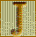
acob Riis hated poverty. Manhattan's overcrowded immigrant tenements made him sick. The lack of playgrounds for kids made him sad. But it was injustice that made him angriest. There was so much wealth in New York, and so much poverty.
Riis photo of a Baxter Street courtyard, circa 1890

Riis knew poverty. A Danish immigrant, he arrived in New York just before the depression of 1873. For a time, he slept in doorways. Then, he got a reporting job and wrote about the city's ghettoes.
In 1885, he turned to photography. The invention of the handheld "detective" camera and the magnesium powder flash made it possible to take pictures in the dark. Most nights, he followed the police. Bursting into saloons, brothels, and gang hang-outs, he would explode his flash and disappear. He also took pictures of poor people packed into their tenements and the horrible conditions of their lives.
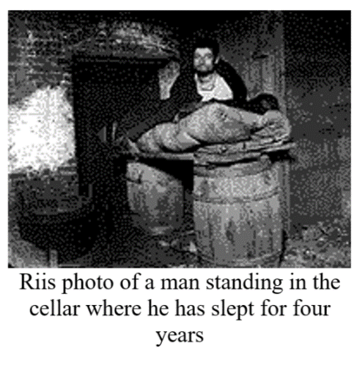
Nobody had ever taken pictures like these before. They were real and they were shocking. In 1890, he published them in his bestseller, HOW THE OTHER HALF LIVES. They helped changed attitudes about the poor. Before Riis, most people who were better-off believed the poor were lazy and deserved their fate. Seeing the photos, many came to share his opinion: society was mainly responsible for poverty by supporting an economic and social system that allowed poverty to exist.
Top right illustration: Courtesy of the National Portrait Gallery, Smithsonian Institution.
Top left illustration: Courtesy of Roger Whitehouse and the Jacob E. Riis Collection, Museum of the City of New York.
Bottom illustrations: Courtesy of the Jacob E. Riis Collection, Museum of the City of New York.

The Industrial East
Processing questions:
- What were some of the indications of poverty Riis noted? What specifics does "The Gilded Age" article offer as evidence of the wealth of the industrialists?
- Was the income disparity noted in the two articles the norm? Is great income disparity part of the process when a nation is undergoing rapid economic growth?
- To what extent do you agree with the idea that "the poor were lazy and deserved their fate?”

- Did the enormous wealth earned by the "captains of industry" eventually benefit everyone through their investments in new factories and their charitable donations?

- Were workers better off in the Industrial Age than they had been before? Did the benefits of industrialization eventually improve the lot of workers? Did benefits come to workers through the actions of the industrialists or through the efforts of the workers themselves or both?

The Homestead Mill Strike
In the space below on the left side, practice summarizing the main ideas of what you read. Highlight/underline important terms/vocab, and define the words you do not know.
When 300 Pinkerton Detectives came ashore at Andrew Carnegie's Homestead mill on July 6, 1892, they had no idea of the extreme violence with which locked-out steelworkers would greet them. A hail of stones, then bullets, ripped the air. Steelworker William Foy and the captain of the Pinkertons fell wounded.
What had begun as a simple disagreement over wages between the nations largest steelmaker and its largest craft union, the Amalgamated Association of Iron and Steel Workers, had taken a decidedly savage turn. Before the struggle ended, Amalgamated would be humbled, Carnegie's control of his labor force complete.
The union fought not just for better wages, but for a say in America's new industrial order. Despite Carnegie's public pro-labor stance, he refused to share control of his company. He and his partner, Henry Clay Frick, had brought unions to heel at their other mills, but Homestead remained untamed. In May, 1892, Carnegie traveled to Scotland, leaving Homestead in Frick's hands. Although Carnegie would later try to distance himself from the events at Homestead, his cables to Frick were clear: Do whatever it takes. Frick dug in for war.
On June 29, despite the union's willingness to negotiate, Frick closed the mill and locked out 3,800 men. Two days later, workers seized the mill and sealed off the town from strike-breakers. Frick summoned a private police force, the Pinkerton Detective Agency, to protect the non-union workers he planned to hire.
Virtually the entire town flooded to the mill to meet the Pinkertons, weapons in hand. "To be confronted with a gang of loafers and cut-throats from all over the country, coming there, as they thought, to take their jobs, why, they naturally wanted to go down and defend their homes and their property and their lives, with force, if necessary," recalled one worker.
For twelve hours, a fierce battle raged. Outgunned by the Pinkertons' Winchester rifles, Homestead's citizens scoured the town for weapons, pressing into service everything from ancient muzzle loaders to a 20-pound cannon. A local hardware merchant donated his entire stock of ammunition, which workers carried to the mill in wheelbarrows. As workers built barricades on shore, the Pinkertons cut rifle ports in the sides of their barges. Meanwhile, news of the battle had reached nearby Pittsburgh. By 6 am more than 5,000 curious spectators lined the riverbanks.
Just before 8 am, in the face of withering gunfire, the Pinkertons again tried to land. From across the Monongahela, workers blasted the cannon at the Pinkertons' barges, but scored few hits. Workers sent a burning raft and even a burning railroad car to destroy the barges, but both fell short of their targets. Dynamite and flaming oil slicks failed to scuttle the Pinkertons' craft.
The terrified Pinkertons cowered below deck. "The noise that they made on shore was awful, and it made us shake in our boots," one Pinkerton said. "We were penned in like rats and we went at the fighting like desperate wild men.... All of our men were under the beds and bunks, crying and trembling."
"It was a place of torment," said another. "Men were lying around wounded and bleeding and piteously begging for someone to give them a drink of water, but no one dared to get a drop, although water was all around us.... It is a wonder we did not all go crazy or commit suicide."
Four times the Pinkertons raised a white flag. Four times it was shot down by one of the three hundred sharpshooters positioned near Open Hearth Furnace no. 1. At 5 PM the workers finally accepted the Pinkertons' surrender. Three workers and seven Pinkertons were dead.
Horrified reporters watched as men, women, and children beat the surrendering Pinkertons brutally. "We were clubbed at every step," one Pinkerton recalled. "Sticks, stones, and dirt were thrown at us. The women pulled us down, spat in our faces, kicked us, and tore our clothing off while the crowd jeered and cheered." Held in the local jail for their safety, the Pinkertons rode the night train out of town.
The violence appalled Carnegie. "The Works are not worth one drop of human blood," he wrote. "I wish they had sunk." Yet he pressed onward. At Frick's request, the Pennsylvania governor sent 8,500 troops to Homestead. "It means just this," said one worker, "that the entire National Guard of the State of Pennsylvania has been called out to enable the Carnegie company to employ scab labor."
The workers welcomed the guardsmen with four brass bands, but failed to engender goodwill. "I don't want any brass-band business while I'm here," said the commanding officer. "I want you to distinctly understand that I am master of this situation." Within twenty minutes, the guardsmen had secured the mill. Homestead was placed under martial law, and by mid-August the mill was in full swing, employing 1700 scab workers.
Public sympathy for the union, eroded by the brutal treatment of the Pinkertons, declined further when anarchist Alexander Berkman, unconnected to the union, attempted to kill Frick. Though seriously wounded, Frick recovered and became even more determined to win: "I will fight this thing to the bitter end. I will never recognize the Union, never, never!" Meanwhile, the mill was being fortified.
Scabs had been assaulted in the street; a non union boarding house dynamited. Many local businesses refused to serve strikebreakers, who included Pennsylvania's first black steelworkers. Barracks, a barber shop and even a saloon were built in the mill yard. Yet even Fort Frick could not provide complete security. In November, tensions exploded into a massive riot against black strikebreakers. Two thousand white workers attacked Homestead's fifty black families. Gunfire was exchanged; many were severely wounded.
In mid-November, the union conceded. Three hundred locked-out men applied for work and were rehired. Many more were blacklisted. "Life worth living again!" Carnegie cabled Frick. "First happy morning since July." With the union crushed, Carnegie slashed wages, imposed twelve-hour workdays, and eliminated 500 jobs. "Oh that Homestead blunder," Carnegie wrote a friend. "But it's fading as all events do & we are at work selling steel one pound for a half penny."
In the space below, summarize the Strike at the Homestead Mill. To what extent were unions successful in the aftermath?
The Homestead Mill Strike
In the space below on the left side, practice summarizing the main ideas of what you read. Highlight/underline important terms/vocab, and define the words you do not know.
One of the most difficult episodes Andrew Carnegie's life -- and one that revealed the steel magnate's conflicting beliefs regarding the rights of labor -- was the bitter conflict in 1892 at his steel plant in Homestead, Pennsylvania. Carnegie's involvement in the union-breaking action left many men dead or wounded and forever tarnished Carnegie's reputation as a benevolent employer and a champion of labor.
The conflict at Homestead arose at a time when the fast-changing American economy had stumbled and conflicts between labor and management had flared up all over the country. In 1892, labor declared a general strike in New Orleans. Coal miners struck in Tennessee, as did railroad switchmen in Buffalo, New York and copper miners in Idaho.
Carnegie's mighty steel industry was not immune to the downturn. In 1890, the price of rolled-steel products started to decline, dropping from $35 a gross ton to $22 early in 1892. In the face of depressed steel prices, Henry C. Frick, general manager of the Homestead plant that Carnegie largely owned, was determined to cut wages and break the Amalgamated Association of Iron and Steel Workers, one of the strongest craft unions in the country.
Behind the scenes, Carnegie supported Frick's plans. In the spring of 1892, Carnegie had Frick produce as much armor plate as possible before the union's contract expired at the end of June. If the union failed to accept Frick's terms, Carnegie instructed him to shut down the plant and wait until the workers buckled. "We... approve of anything you do," Carnegie wrote from England in words he would later come to regret. "We are with you to the end."
With Carnegie's carte blanche support, Frick moved to slash wages. Plant workers responded by hanging Frick in effigy. At the end of June, Frick began closing down his open hearth and armor-plate mills, locking out 1,100 men. On June 25th, Frick announced he would no longer negotiate with the union; now he would only deal with workers individually. Leaders of Amalgamated were willing to concede on almost every level -- except on the dissolution of their union. Workers tried to reach the Carnegie who had strongly defended labor's right to unionize. He had departed on his annual and lengthy vacation, traveling to a remote Scottish castle on Loch Rannoch. He proved inaccessible to all -- including the press and to Homestead's workers -- except for Frick.
"This is your chance to re-organize the whole affair," Carnegie wrote his manager. "Far too many men required by Amalgamated rules." Carnegie believed workers would agree to relinquish their union to hold on to their jobs.
It was a severe miscalculation. Although only 750 of the 3,800 workers at Homestead belonged to the union, 3,000 of them met and voted overwhelmingly to strike. Frick responded by building a fence three miles long and 12 feet high around the steelworks plant, adding peepholes for rifles and topping it with barbed wire. Workers named the fence "Fort Frick." Deputy sheriffs were sworn in to guard the property, but the workers ordered them out of town. Workers then took to guarding the plant that Frick had closed to keep them out. This action signified a very different attitude that labor and management shared toward the plant.
"Workers believed because they had worked in the mill, they had mixed their labor with the property in the mill," explains historian Paul Krause. "They believed that in some way the property had become theirs. Not that it wasn't Andrew Carnegie's, not that they were the sole proprietors of the mill, but that they had an entitlement in the mill. And I think in a fundamental way the conflict at Homestead in 1892 was about these two conflicting views of property."
Frick turned to the enforcers he had employed previously: the Pinkerton Detective Agency's private army, often used by industrialists of the era. At midnight on July 5, tugboats pulled barges carrying hundreds of Pinkerton detectives armed with Winchester rifles up the Monongahela River. But workers stationed along the river spotted the private army. A Pittsburgh journalist wrote that at about 3 A.M. a "horseman riding at breakneck speed dashed into the streets of Homestead giving the alarm as he sped along." Thousands of strikers and their sympathizers rose from their sleep and went down to the riverbank in Homestead.
When the private armies of business arrived, the crowd warned the Pinkertons not to step off the barge. But they did. No one knows which side shot first, but under a barrage of fire, the Pinkertons retreated back to their barges. For 14 hours, gunfire was exchanged. Strikers rolled a flaming freight train car at the barges. They tossed dynamite to sink the boats and pumped oil into the river and tried to set it on fire. By the time the Pinkertons surrendered in the afternoon three detectives and nine workers were dead or dying. The workers declared victory in the bloody battle, but it was a short-lived celebration.
The governor of Pennsylvania ordered state militia into Homestead. Armed with the latest in rifles and Gatling guns, they took over the plant. Strikebreakers who arrived on locked trains, often unaware of their destination or the presence of a strike, took over the steel mills. Four months after the strike was declared, the men's resources were gone and they returned to work. Authorities charged the strike leaders with murder and 160 other strikers with lesser crimes. The workers' entire Strike Committee also was arrested for treason. However, sympathetic juries would convict none of the men. All the strikers leaders were blacklisted. The Carnegie Company successfully swept unions out of Homestead and reduced it to a negligible factor in the steel mills throughout the Pittsburgh area.
Carnegie found the upheaval and its aftermath a devastating experience. When British statesman William E. Gladstone wrote him a sympathetic note, Carnegie replied:
This is the trial of my life (death's hand excepted). Such a foolish step -- contrary to my ideals, repugnant to every feeling of my nature. Our firm offered all it could offer, even generous terms. Our other men had gratefully accepted them. They went as far as I could have wished, but the false step was made in trying to run the Homestead Works with new men. It is a test to which workingmen should not be subjected. It is expecting too much of poor men to stand by and see their work taken by others. . . The pain I suffer increases daily. The Works are not worth one drop of human blood. I wish they had sunk.
Carnegie would come back to Homestead six years later to dedicate a building that would house a library, a concert hall, a swimming pool, bowling alleys, and a gymnasium. However, the man who saw himself as a progressive businessman would always carry pain regarding the incident. "Nothing. . . in all my life, before or since, wounded me so deeply," he wrote in his autobiography. "No pangs remain of any wound received in my business career save that of Homestead."
"It's easy to say that Carnegie was a hypocrite," states historian Joseph Frazier Wall. "And there is an element of hypocrisy clearly in between what he said and what was done. But it's a little too easy to simply dismiss the whole incident on Carnegie's part as an act of hypocrisy. There is this curious reason as to why Carnegie felt it necessary to even enunciate the rights of labor. Frick was the norm, not Carnegie, in management's relationship with labor at that time. And, one can only answer that, once again, it's being torn between wanting to pose as a great democrat and liberal and at the same time wanting to make sure Carnegie Steel came out on top."
In the space below, summarize the Strike at the Homestead Mill. To what extent was Carnegie responsible?

The Musical Saga of Homestead
Workers sang during strikes not only to state their beliefs and goals, but because singing helped bind workers together. The Homestead strike of 1892 even had its own Homestead Strike Songster, and the story of the strike can be traced in the lyrics of the following four songs. “The Homestead Strike” explained that Carnegie’s efforts to “lower our wages” was the basic cause of the strike. The death of nine strikers was chronicled in “Father Was Killed by the Pinkerton Men.” And “Song of a Strike,” written by George Swetnam, retrospectively commemorated the Homestead strikers' courage in defending their homes and their jobs against the overwhelming might of the Carnegie Steel Company and their hired "bum detectives."

“The Homestead Strike”
Now, boys, we are out on strike, you can help us if you like,
But you need not till I tell you what it’s about.
They want to lower our wages, we think it is not right;
So for union’s cause I want you all to shout.
We will sing the union’s praise while our voices we can raise,
With noble Mr. Garland at our head,
Hugh O’Donnell’s good, that’s true, we give him all the praise;
We can’t go wrong when by such men we’re led.
The struggle may be long, there’s no one yet can say,
But we’ll take it as it comes for a little while;
We will fight both night and day, for we’re bound to win the day,
And down this great steel king in grandest style.
Now let us all stand firm and take things very cool,
Then, you bet, we’re sure to win this little strike;
But if men don’t mind and start and act a fool,
That’s sure to cause no end of care and strife.
My advice to you is this, let us work with a cool head,
And try and do the best thing in our power;
We’ll have the good will of all, which will bring us back our bread,
And drive the demon Hunger from our door.
Let us unite with heart and hand and spread the news through this broad land,
We’ll not give in until the company yield,
And fight with might and main and travel hand in hand
To win this strike or die upon the field.

“Father Was Killed by the Pinkerton Men”
'Twas in a Pennsylvania town not very long ago
Men struck against reduction of their pay
Their millionaire employer with philanthropic show
Had closed the works till starved they would obey
They fought for home and right to live where they had toiled so long
But ere the sun had set some were laid low
There’re hearts now sadly grieving by that sad and bitter wrong
God help them for it was a cruel blow.
CHORUS:
God help them tonight in their hour of affliction
Praying for him whom they’ll ne’er see again
Hear the orphans tell their sad story
“Father was killed by the Pinkerton men.”
Ye prating politicians, who boast protection creed,
Go to Homestead and stop the orphans' cry.
Protection for the rich man ye pander to his greed,
His workmen they are cattle and may die.
The freedom of the city in Scotland far away
'Tis presented to the millionaire suave,
But here in Free America with protection in full sway,
His workmen get the freedom of the grave.

Source: "The Homestead Strike": The Homestead Strike Songster (New York: n.d.). Reprinted in Philip S. Foner, American Labor Songs of the Nineteenth Century (Urbana: University of Illinois Press, 1975), 243.
“Father Was Killed by the Pinkerton Men”: Sigmund Spaeth, Weep Some More, My Lady (Garden City, N.Y.: 1927), 235–236. Reprinted in Phillip S. Foner, American Labor Songs of the Nineteenth Century (Urbana: University of Illinois Press, 1975), 244.

Triangle Shirtwaist Factory Fire
In the space below on the left side, practice summarizing the main ideas of what you read. Highlight/underline important terms/vocab, and define the words you do not know.
The fire at the Triangle Waist Company in New York City, which claimed the lives of 146 young immigrant workers, is one of the worst disasters since the beginning of the Industrial Revolution. This incident has had great significance to this day because it highlights the inhumane working conditions to which industrial workers can be subjected. To many, its horrors epitomize the extremes of industrialism. The tragedy still dwells in the collective memory of the nation and of the international labor movement. The victims of the tragedy are still celebrated as martyrs at the hands of industrial greed.

The Triangle Waist Company was in many ways a typical sweated factory in the heart of Manhattan, at 23-29 Washington Place, at the northern corner of Washington Square East. Low wages, excessively long hours, and unsanitary and dangerous working conditions were the hallmarks of sweatshops.

Even though many workers toiled under one roof in the Asch building, owned by Max Blanck and Isaac Harris, the owners subcontracted much work to individuals who hired the hands and pocketed a portion of the profits. Subcontractors could pay the workers whatever rates they wanted, often extremely low. The owners supposedly never knew the rates paid to the workers, nor did they know exactly how many workers were employed at their factory at any given point. Such a system led to exploitation.

Even today, sweatshops have not disappeared in the United States. They keep attracting workers in desperate need of employment and undocumented immigrants, who may be anxious to avoid involvement with governmental agencies. Recent studies conducted by the U.S. Department of Labor found that 67% of Los Angeles garment factories and 63% of New York garment factories violate minimum wage and overtime laws. Ninety-eight percent of Los Angeles garment factories have workplace health and safety problems serious enough to lead to severe injuries or death.

The International Ladies' Garment Workers Union organized workers in the women's clothing trade. Many of the garment workers before 1911 were unorganized, partly because they were young immigrant women intimidated by the alien surroundings. Others were more daring, though. All were ripe for action against the poor working conditions. In 1909, an incident at the Triangle Factory sparked a spontaneous walkout of its 400 employees. The Women's Trade Union League, a progressive association of middle class white women, helped the young women workers picket and fence off thugs and police provocation. At a historic meeting at Cooper Union, thousands of garment workers from all over the city followed young Clara Lemlich's call for a general strike.

With the cloakmakers' strike of 1910, a historic agreement was reached, that established a grievance system in the garment industry. Unfortunately for the workers, though, many shops were still in the hands of unscrupulous owners, who disregarded basic workers' rights and imposed unsafe working conditions on their employees.

Near closing time on Saturday afternoon, March 25, 1911, a fire broke out on the top floors of the Asch Building in the Triangle Waist Company. Within minutes, the quiet spring afternoon erupted into madness, a terrifying moment in time, disrupting forever the lives of young workers. By the time the fire was over, 146 of the 500 employees had died. The survivors were left to live and relive those agonizing moments. The victims and their families, the people passing by who witnessed the desperate leaps from ninth floor windows, and the City of New York would never be the same.

Many of the Triangle factory workers were women, some as young as 14 years old. They were, for the most part, recent Italian and European Jewish immigrants who had come to the United States with their families to seek a better life. Instead, they faced lives of grinding poverty and horrifying working conditions. As recent immigrants struggling with a new language and culture, the working poor were ready victims for the factory owners. For these workers, speaking out could end with the loss of desperately needed jobs, a prospect that forced them to endure personal indignities and severe exploitation. Some turned to labor unions to speak for them; many more struggled alone. The Triangle Factory was a non-union shop, although some of its workers had joined the International Ladies' Garment Workers' Union.
New York City, with its tenements and loft factories, had witnessed a growing concern for issues of health and safety in the early years of the 20th century. Groups such as the International Ladies' Garment Workers' Union (ILGWU) and the Womens' Trade Union League (WTUL) fought for better working conditions and protective legislation. The Triangle Fire tragically illustrated that fire inspections and precautions were woefully inadequate at the time. Workers recounted their helpless efforts to open the ninth floor doors to the Washington Place stairs. They and many others afterwards believed they were deliberately locked-- owners had frequently locked the exit doors in the past, claiming that workers stole materials. For all practical purposes, the ninth floor fire escape in the Asch Building led nowhere, certainly not to safety, and it bent under the weight of the factory workers trying to escape the inferno. Others waited at the windows for the rescue workers only to discover that the firefighters' ladders were several stories too short and the water from the hoses could not reach the top floors. Many chose to jump to their deaths rather than to burn alive.

Protesting voices arose, bewildered and angry at the lack of concern and the greed that had made this possible. The people demanded restitution, justice, and action that would safeguard the vulnerable and the oppressed. Outraged cries calling for action to improve the unsafe conditions in workshops could be heard from every quarter, from the mainstream conservative to the progressive and union press. Workers flocked to union quarters to offer testimonies, support mobilization, and demand that Triangle owners Harris and Blanck be brought to trial. The role that strong unions could have in helping prevent such tragedies became clear. Workers organized in powerful unions would be more conscious of their rights and better able to obtain safe working conditions.

Immediately after the fire, Triangle owners Blanck and Harris declared in interviews that their building was fireproof, and that it had just been approved by the Department of Buildings. Yet the call for bringing those responsible to justice and reports that the doors of the factory were locked at the time of the fire prompted the District Attorney's office to seek an indictment against the owners. On April 11, a grand jury indicted Harris and Blanck on seven counts, charging them with manslaughter in the second degree under section 80 of the Labor Code, which mandated that doors should not be locked during working hours.

On December 27, twenty-three days after the trial had started, a jury acquitted Blanck and Harris of any wrongdoing. Twenty-three individual civil suits were brought against the owners of the Asch building. On March 11, 1914, three years after the fire, Harris and Blanck settled. They paid 75 dollars per life lost.

Harris and Blanck were to continue their defiant attitude toward the authorities. Just a few days after the fire, the new premises of their factory had been found not to be fireproof, without fire escapes, and without adequate exits.
In August of 1913, Max Blanck was charged with locking one of the doors of his factory during working hours. Brought to court, he was fined twenty dollars, and the judge apologized to him for the imposition. In December of 1913, the interior of his factory was found to be littered with rubbish piled six feet high, with scraps kept in non-regulation, flammable wicker baskets. This time, instead of a court appearance and a fine, he was served a stern warning. The Triangle Waist Company was to cease operations in 1918, but the owners maintained throughout that their factory was a "model of cleanliness and sanitary conditions," and that it was "second to none in the country."
In the space below, summarize what the Triangle Shirtwaist Factory Fire was. To what extent were unions successful in the aftermath of this disaster?

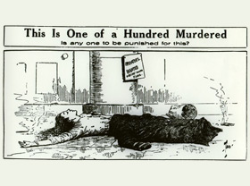
147 Dead, Nobody Guilty

Literary Digest, January 6, 1912. p. 6.
Nine months ago 147 persons, chiefly young women and girls, were killed by a fire in the factory of the Triangle Waist Company at Washington Place and Greene Street, of New York. All of the subsequent evidence, as well as the facts of the tragedy, convinced that New York papers that this factory where hundreds of girls were compelled by circumstances to work for their livings was a veritable fire-trap, though not worse, perhaps, than hundreds of buildings in the city. Last week, Issac Harris and Max Blanck, owners of the Triangle Company, under trial for manslaughter in the first or second degree, were acquitted by a New York jury on their third ballot, after being out an hour and forty-five minutes. While the press in the main seem inclined to accept the verdict itself without serious challenge, many papers are gravely troubled over its practical implication that no one is responsible for that wholesale slaughter, and the feeling is widely exprest that, whatever the explanation of the outcome, justice has in fact been balked. It is "one of the disheartening failures of justice which are all too common in this country," declares the New York Tribune, which goes to say:
The point of view of those who must day after day submit themselves to risks similar to those which obtained in the Triangle factory in thus voiced by the New York Call (Socialist):
There are no guilty. There are only the dead, and the authorities will forget the case as speedily as possible. Capital can commit no crime when it is in pursuit of profits.
Of course, it is well known that those who were killed in the Triangle disaster are only part, and a small part, of those murdered in industry during the passing year. There are only 147 incinerated and mangled. But there were thousands of others who met a similarly agonizing fate during this year of 1911.
The whole capitalist system is based upon such unspeakable systematic murder, and those who defend the capitalist system defend those murders.
Perhaps the men on the jury had no thought of condoning murder, but that is what they did. They freed of the punishment legal guilt might bring two men who profited by the conditions that made such a disaster inevitable. They did it because they recognized the basic fact that their own interests were in involved in such an action. They stood by their fellow manufacturers and set them free.
But the verdict of the jury in this case by no means settles it. There is another jury that considers the matter, and it is not made up alone of stricken relatives of the murdered women. It is made up of the entire working class. For that horrible murder in the Asch building was one that concerned the whole working class because it was typical of the conditions under which they must gain their daily bread.
And the verdict of the great jury undoubtedly is that not only are Harris and Blanck guilty, but that the whole class to which they belong is guilty, and is foul with the blood of the workers.
It was a fair trial, says the New York Sun, and the New York Herald agrees that the verdict is not surprising, in view of the contradictory evidence presented. The Brooklyn Eagle sees in the result of vindication of the principle of the jury trial, and the New York Press can not regard the acquittal of the Triangle owners as a miscarriage of justice. Says the Press:
The blood of those victims was on more than two heads; on more than twenty heads, perhaps on more than a million heads. Everybody connected with the actual neglect of the fire and building laws, whether in an official or unofficial capacity, shared in the blame.
It was a blind passion for revenge, and not a sound conviction that these men were exclusively responsible for the sacrifice of those lives, that inspired clamor by a large body of the community for their punishment.
Nevertheless one of the jurors has since declared that after this I have no faith in jury trials, and another announced through the press: I know I didn't do my duty to the people, but the court's charge prevented. The point in Judge Crain's charge, to the jury here referred to related to the locking of the Washington
Place door on the ninth floor, where dozens of the victims met their death. Said Judge Crain:
Because they are charged with a felony, I charge you that before you find these defendants guilty of manslaughter in the first degree, you must find this door was locked. If it was locked and locked with the knowledge of the defendants, you must also find beyond a reasonable doubt that such locking caused the death of Margaret Schwartz. If these men were charged with a misdemeanor I might charge you that they need have no knowledge that the door was locked, but I think that in this case it is proper for me to charge that they must have personal knowledge of the fact that it was locked.

The juror whose conscience now troubles him is Victor Steinman. To a reporter from the New York Evening Mail he said:

I believed that the Washington Place door, on which the district-attorney said the whole case hinged, was locked at the time of the fire. But I could not make myself feel certain that Harris and Blanck knew that it was locked. And so, because the judge had charged us that we could not find them guilty unless we believed that they knew the door was locked then, I did not know what to do.

It would have been a much easier for me if the State factory inspectors instead of Harris and Blanck had been on trial. For there would have been no doubt in my mind then as to how to vote.

Their duties are clearly outlined by the law. It was up to them, more than to Harris and Blanck, to see that the door was not locked. But they were not on trial. Yet all the time I was refusing to vote I kept thinking about them.

Asked why he could not feel beyond a reasonable doubt that the owners knew the door was to be locked, Mr. Steinman answered:

Because the evidence was so conflicting and because so many of the witnesses on each side were lying. They told their stories like parrots, and I could not believe them.

All I felt sure of was that the door had been locked. I believed that piece of charred wood and the lock with the shot bolt that the State put into evidence. But then I believed also the testimony that the key was usually in the door and that it was tied to it with a piece of string.

So there was the thought in my mind that during the first rush for the door some panic-stricken girl might have turned the key in an effort to open it. And if that was so, then Harris and Blanck could not have known of it, as the judge demanded they should, to be convicted.

A number of other manslaughter indictments are still pending against Harris and Blanck, altho there seems to be some doubt as to whether they will ever be brought to trial on them. The case which has resulted in their acquittal was regarded as the strongest of all cases against them.

The Haymarket Affair Digital Collection
The Haymarket Affair Narrative  What has come to be known as the Haymarket Affair began on May 3, 1886, when Chicago police fired into a crowd of striking workers at the McCormick Reaper Works, killing and wounding several men. The following evening, anarchist and socialist labor leaders organized a meeting of workingmen near Chicago's Haymarket Square. Speakers at the meeting denounced the police attack of the previous afternoon and urged workers to intensify their struggle for an eight-hour workday and other improvements in labor conditions.  Just as the meeting was breaking up, the police, led by Captain William Ward and Inspector John Bonfield, arrived on the scene and attempted to disperse the crowd. During this effort, someone threw a dynamite bomb into the ranks of the police, killing one officer outright and injuring others. A melee ensued, the police, and probably others in the crowd, fired shots. Seven police officers were killed or mortally wounded, and one died of his wounds several years later. How many casualties the workers sustained that evening is not known, as those who fell were quickly dragged to safety or to medical attention by their comrades. | 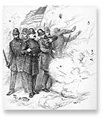
The unknown bomber's act resounded nationwide. Public opinion was instantly galvanized against the radical left, resulting in the first "Red Scare" in America. In a climate of political paranoia fueled by the popular press, the police arrested eight prominent Chicago anarchists and charged them with conspiracy to murder. The eight were tried before Judge Joseph E. Gary in the Circuit Court of Cook County. Although no evidence emerged to tie any of the men to the bombing, the jury returned a verdict of guilty after deliberating for less than three hours. The court sentenced Oscar Neebe to fifteen years in the penitentiary and the others to death by hanging.
The attorneys for the defense immediately appealed the verdict to the Illinois Supreme Court which upheld the verdict against the anarchists on September 14, 1887. The defense then petitioned the U.S. Supreme Court for a writ of error. After three days of testimony by counsel for the convicted, however, the Supreme Court dismissed the petition on November 2, 1887, leaving amnesty as the only remaining option for the defendants.
On November 11, 1887, Albert Parsons, August Spies, George Engel, and Adolph Fischer were hanged. Louis Lingg escaped the hangman's noose by committing suicide in his cell the day before he was scheduled to climb the scaffold. Illinois governor Richard Oglesby commuted the sentences of Samuel Fielden and Michael Schwab to life in prison. In 1893, Oglesby's successor, John Peter Altgeld, pardoned the three surviving defendants, Fielden, Schwab, and Neebe, at the cost of his own political career.
The Haymarket Affair was a momentous and controversial event in Chicago's history and in the history of the American labor movement. In Chicago, a monument was erected in Haymarket Square to memorialize the police officers who lost their lives. Throughout the United States and Europe the executed anarchists became known as "the martyrs of Chicago."

The Case for Sweatshops
by David R. Henderson (Research Fellow)
Candida Rosa Lopez, an employee in a Nicaraguan garment factory, works long hours over a sewing machine at less than a dollar an hour. Interviewed recently by a Miami Herald reporter, Ms. Lopez has a message for people in the United States and other wealthy countries who are nervous about buying goods from "sweatshops": "I wish more people would buy the clothes we make."
Contrary to what you have heard, sweatshops in third-world countries are a good deal for the people who work in them. Why? Because work, other than slave labor, is an exchange. A worker chooses a particular job because she thinks herself better off in that job than at her next-best alternative. Most of us would regard a low-paying job in Nicaragua or Honduras as a lousy job. But we're not being asked to take those jobs. Those jobs are the best options those workers have, or else they would quit and work elsewhere. You don't make someone better off by taking away the best of a bunch of bad choices.
Many workers in third-world sweatshops have left even harder, lower-paying jobs in agriculture to move to garment factories. Moreover, sweatshops are a normal step in economic development. Singapore, Malaysia, South Korea, and Hong Kong all had sweatshop jobs thirty years ago. They don't now because workers in those countries have acquired skills and employers have accumulated capital. That's what will happen in Honduras, Nicaragua, and other poor countries—if we only let it.

What happens when people persuade companies not to hire children to work long hours? Oxfam, the British charity, reported that when factory owners in Bangladesh were pressured to fire child laborers, thousands of the children became prostitutes or starved.
Yet the National Labor Committee's executive director, Charles Kernaghan, goes around the country attacking sweatshops and trying to put legal barriers in the way of people buying from sweatshops. Robert Reich, former U.S. labor secretary under President Clinton, pressured Reebok International and Sears Roebuck to get ShinWon, their South Korean subcontractor in Honduras, to lay off fifty teenage girls. He apparently did not ask, or care, what happened to them after they lost their jobs. Why are Kernaghan and Reich hurting the people they claim to care about? Simple. The people they really care about are unionized garment workers in the United States; the NLC is funded by U.S. unions. The garment workers lost on NAFTA and lost on GATT. This is their last-ditch effort to prevent foreign competition.
The next time you feel guilty for buying clothes made in a third-world sweatshop, remember this: you're helping the workers who made that clothing. The people who should feel guilty are those who argue against, or use legislation to prevent us, giving a boost up the economic ladder to members of the human race unlucky enough to have been born in a poor country. Someone who intentionally gets you fired is not your friend.

Top Clothing Retailers Labeled Labor Abusers Sweatshops Allegedly Run on U.S. Territory
The Washington Post

By William Branigin
Washington Post Staff Writer
Thursday, January 14, 1999; Page A14

In a battery of lawsuits filed on behalf of more than 50,000 foreign workers, major U.S. retailers were accused yesterday of engaging in a "racketeering conspiracy" to produce clothing in sweatshop conditions using indentured labor on a U.S. island territory.
Two federal class action suits and a companion suit in California state court seek more than $1 billion in damages, unpaid wages and returned corporate profits. Among 18 U.S. retailers and manufacturers named in the suits are The Gap, Tommy Hilfiger, Sears, Wal-Mart, Oshkosh B'Gosh and the companies that own various department stores, including Lord and Taylor's, Hecht's and Mervyn's.
In addition, 22 garment factories in the Commonwealth of the Northern Mariana Islands are charged with failing to pay overtime and imposing intolerable work and living conditions on their employees. The factories are owned predominantly by Chinese and South Korean interests and employ mostly women from China, the Philippines, Bangladesh and Thailand.
Tracy Mullin, president of the National Retail Federation, the trade association of the retailers named in the suits, said they "seek to do business only with the most reputable manufacturers" and favor "vigorous enforcement" of labor laws by federal authorities. Spokesmen for the factories, located on the commonwealth's main island of Saipan, deny the existence of sweatshop conditions there.
The two federal suits were filed in U.S. district courts in Los Angeles and Saipan on behalf of current and former garment workers, who allegedly were forced to work at least 70 hours a week without overtime in unhealthy and sometimes hazardous conditions and were often confined to crowded, vermin-infested "barracks" while off duty.
A third suit, filed in California state court by labor and human rights groups, accuses retailers of violating a state law against fraudulent and unfair business practices.
"On an island where thousands of American soldiers died during World War II, thousands of young Asian women are forced to endure slavery so that . . . corporate profits can be higher," said William S. Lerach, a lead attorney for the plaintiffs.

Representative George Miller (D-California) said the suits mark "a critical step toward ending years of human rights and labor violations that are sanctioned by the local government, taken advantage of by American companies and protected by Republican leaders of Congress . . . who have blocked bipartisan reform legislation."
Carmencita Abad, a former garment worker from the Philippines who worked on Saipan for six years, told a news conference in New York that she suffered retaliation for trying to form a union and help Chinese co-workers.
She said many workers pay as much as $7,000 to recruiters to get the jobs, often live eight to a room, must buy bug-infested food from the factory owners and routinely earn much less than the local $3.15-an-hour minimum wage because they are forced to "donate" up to 20 additional working hours a week to the factory. "If they complain," Abad said. "Chinese workers can be beaten or punished."
"This abuse occurs while U.S. retailers watch," she said. "I have seen many times the Gap inspector come into the factory, look at the garments and fabric, then turn and walk out the door." She said the retailer's "code of conduct" is posted, but only in English, which the Chinese workers cannot read.
"We are deeply concerned by the allegations," the company said in a statement. "Gap Inc. does not tolerate this type of conduct in the factories where we do business."

After reading the articles, fill in the Venn diagram below.

- What are similarities and differences between modern-day sweatshops and late-19th century factories?
- What justification does Henderson give for why sweatshops are positive?
- What justification does Branigin give for why sweatshops are negative?

- Which do you agree with more, and why? Answer in at least four full sentences.

