Guns, Germs, and Steel
Pre-Write Activity

Using your knowledge from the Jared Diamond reading and the diagram below, you will complete a thesis statement for an essay prompt on the back of this page.

A thesis statement is your main argument. It’s your main point. In essays, you always need to support your main argument – the point you’re trying to make – with tons of evidence.

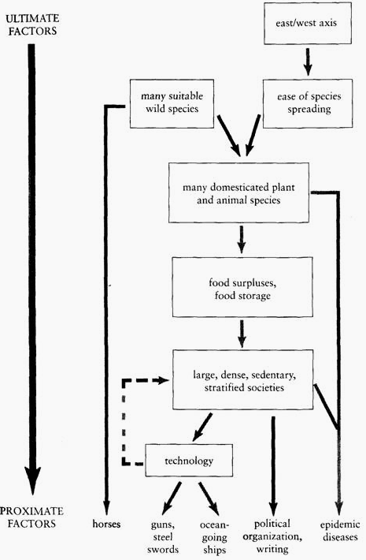

Ultimately, the above graph shows Jared Diamond’s thesis – his main argument – that Eurasia’s east/west axis allowed it to dominate the rest of the world. Due to that east/west axis, all of the below happened faster in Eurasian societies, and didn’t happen in African, American, and Oceanic societies, due to isolation (the Sahara, Atlantic, and Pacific, respectively) and their north/south axis.

Prompt:
What was the most significant proximate factor that led to Eurasian dominance of world history?
*note: proximate factors are horses, guns/steel swords, ocean-going ships, political organization and writing, and epidemic diseases.

Step 1: Brainstorm!
You know things about world history. You might not know a ton about Asia yet, but you know that the Europeans conquered Africa and the Americas. Out of the five proximate factors above, which two or three do stand out to you? Why? Brainstorm for those two or three below, and, based on which on you can support the best with the most evidence, use that one as your answer!

Step 2: Write!
Thesis statements are fun! They need to be analytical – aka, tell me the “how” and “why.” Restate the prompt, and then use the word “because.” I also love having a counterargument in thesis statements – “Although …, the proximate factor that helped Eurasia dominate world history was …, because …”
Try it out below!

____________________________________________________________________________________________________________________________________________________________________________________________________________________________________________________________________________________________________________________________________________________________________________________________________________________________________________________________________________________________________________________________________________________________________________________________________________

