Poster Project: DBQ

Instead of individually writing the answer to this DBQ prompt, you will be working in groups and will be responsible for creating a DBQ poster project. You can work in groups of 1-3 people.

Step 1: Analyze each document

- As a group, read through the background essay and documents below. After each document, formulate a concise statement of how you would use that document as evidence in writing this DBQ.
  - Don’t cite the document – paraphrase it in your own words.
  - This should be one to two sentences.
    - In one sentence, explain what the document is.
    - In your second sentence, explain how that document answers the prompt – how that document shows how Islam spread
- As you are working your way though the documents, keep note of PIECES themes. At the end, you will need to group the documents into at least three PIECES themes of your choosing.
  - Note: if you want to be more specific in some of your PIECES themes (example – talk about military instead of just ‘politics,’ you can!)

Step 2: CP Arts and Crafts (day 2)

- Once you have finished reading through and analyzing documents, cut each document out, and begin grouping the documents by theme.
- Glue/tape the documents in their groups onto a poster sheet of paper. Label your groups.

Step 3: Introduction and thesis
- Create a two-three sentence historical context introduction. Write this at the top of your poster.
  - What is going on in the world at the time? Think of this as a “previously on…” before a new episode. Zoom out and give me some context.
- Then, write an analytical thesis statement that directly answers the prompt.
  - Directly restate the prompt. “During the time period 600-1450, Islam spread because of ….” You should have as many reasons in your thesis statement as you have themes on your poster.
  - Be more specific than “because of political, economic, and social reasons.”
  - For one extra point, use a counterargument in your thesis.
    - This can be the theme that you think contributed the least to Islam’s spread.
    - “Although ___ contributed to the spread of Islam, the main factors that led to the spread of Islam from 600-1450 were __ and __.”
  - Want a formula?
Although X, Y, because A and B.
Where X is your counterargument, Y is your actual argument, and A and B are reasons that support your actual argument.

This is worth one test grade!
Extra credit:
- Create a topic sentence for each of your grouped documents. (out of 2pts per, max 6 pts)
  - This summarizes the prompt in relation to your chosen PIECES theme
- Analyze EITHER perspective or intended audience from one of the documents. The document must be a primary source. (max 2 pts)
  - How does the author’s perspective (point of view) impact our understanding of the document?
Brainstorming space:
Historical Context:

Thesis statement:

Groups: (list documents and themes)

Background information essay: after you read the essay, predict reasons below before you begin looking at the documents.
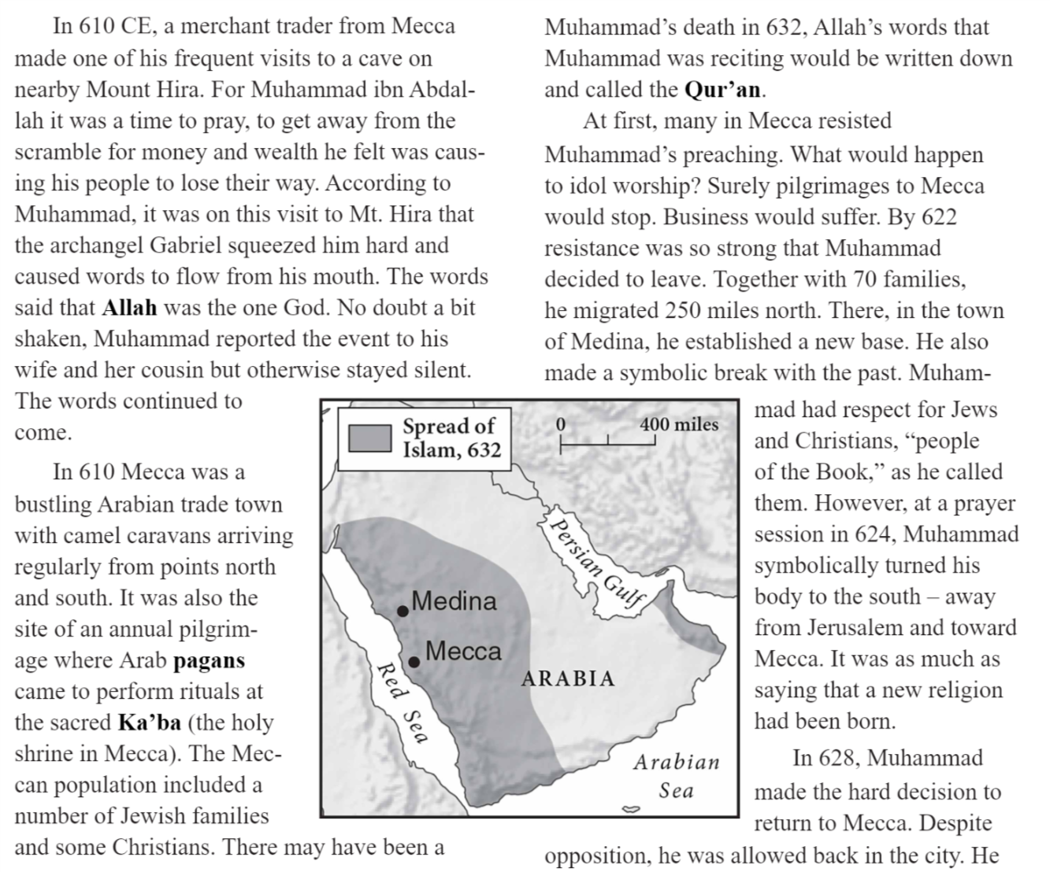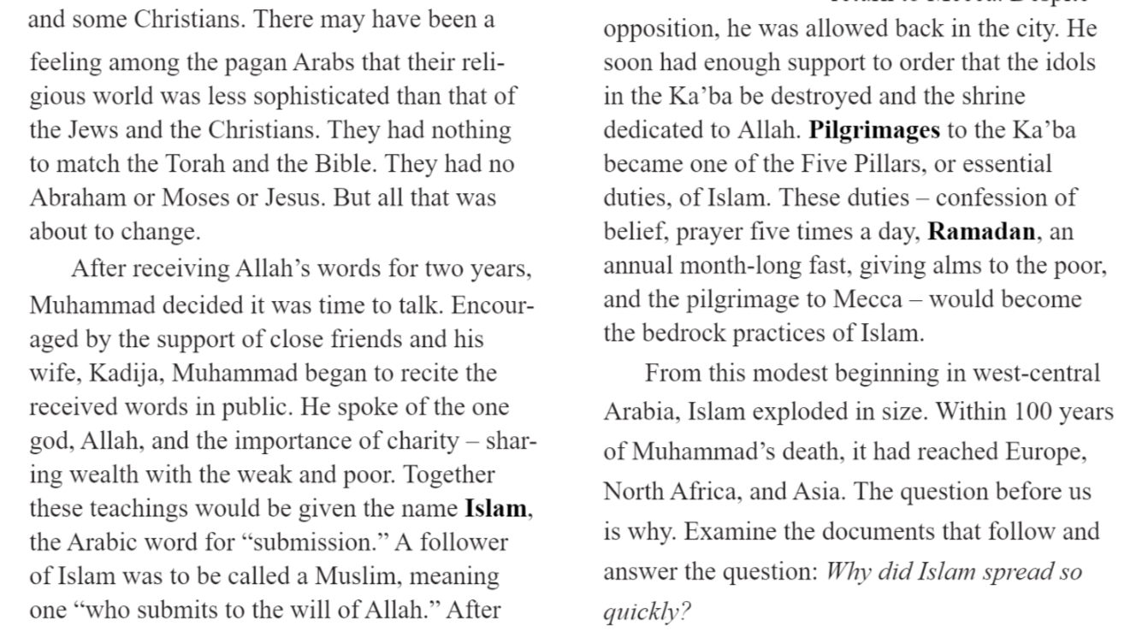
DOCUMENT 1:
Based on the following documents, analyze the factors that facilitated the spread of the Islam across Afro-Eurasia from 600–1450.

But how?
Source: Historian Kallie Szcepanski, “The Spread of Islam in Asia, 632CE to Present.”
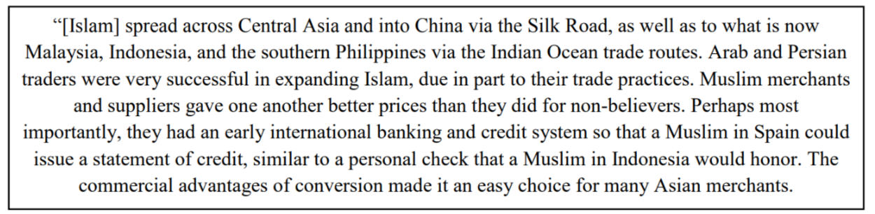

How would you use this document to answer the prompt?
______________________________________________________________________________________________________________________________________________________________________________________________________________________________________________________________________________
DOCUMENT 2:
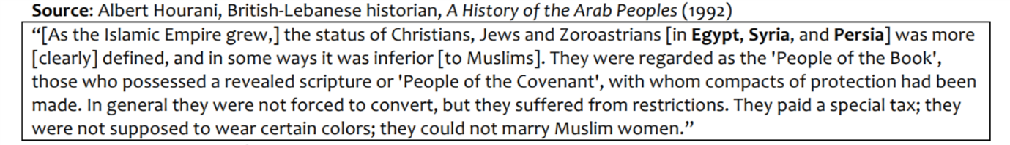

How would you use this document to answer the prompt?
______________________________________________________________________________________________________________________________________________________________________________________________________________________________________________________________________________

DOCUMENT 3:
How would you use this document to answer the prompt?

______________________________________________________________________________________________________________________________________________________________________________________________________________________________________________________________________________
DOCUMENT 4:
How would you use this document to answer the prompt?

______________________________________________________________________________________________________________________________________________________________________________________________________________________________________________________________________________

DOCUMENT 5:
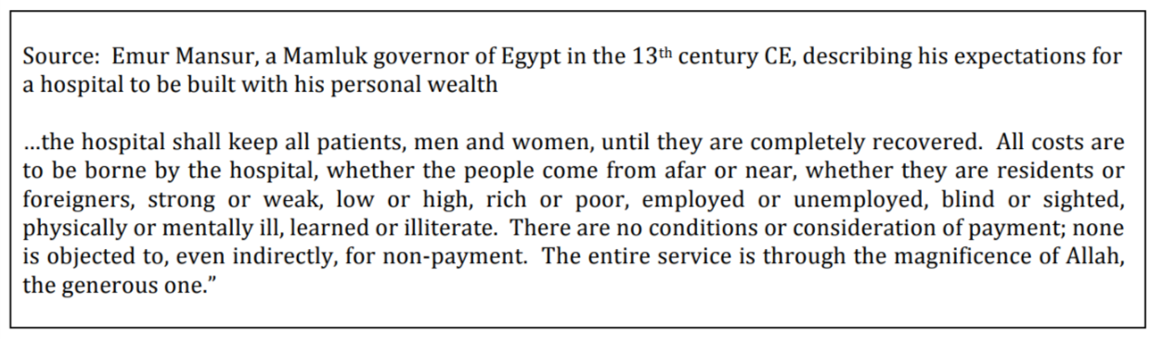
How would you use this document to answer the prompt?
______________________________________________________________________________________________________________________________________________________________________________________________________________________________________________________________________________

DOCUMENT 6:

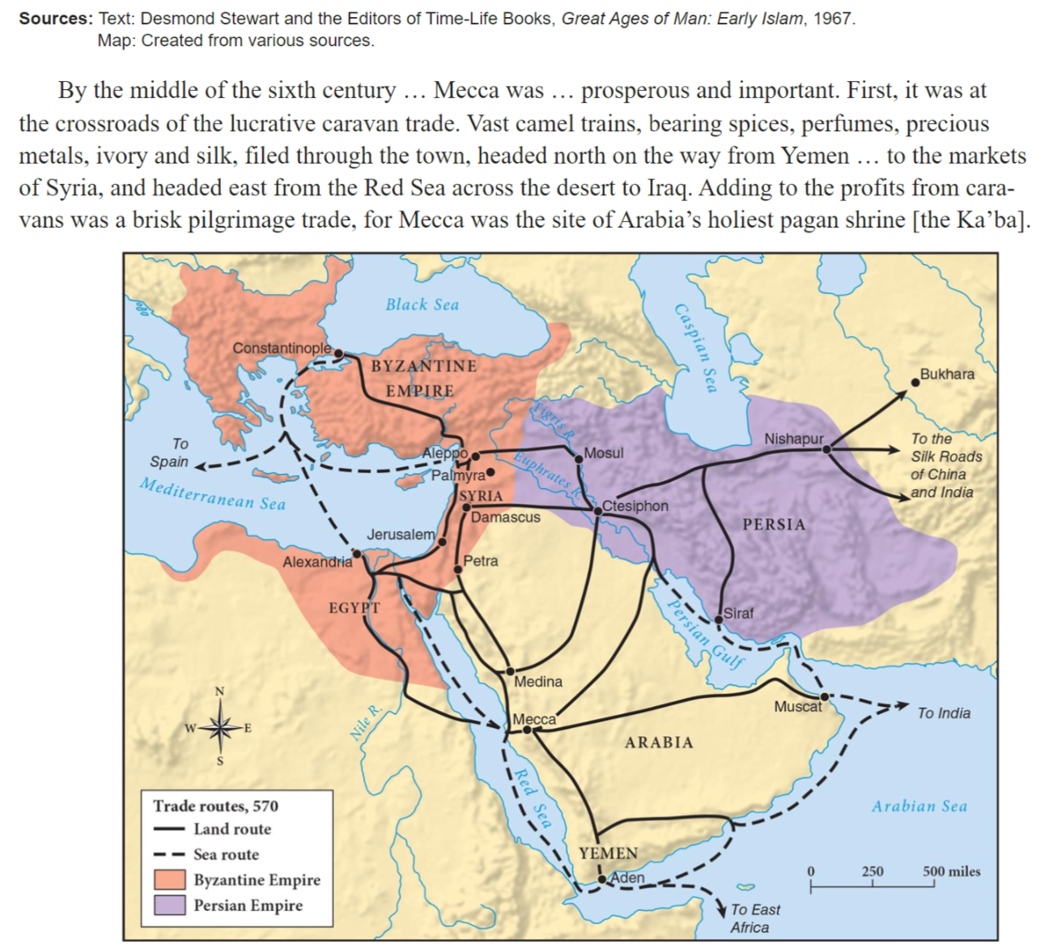

How would you use this document to answer the prompt?
______________________________________________________________________________________________________________________________________________________________________________________________________________________________________________________________________________
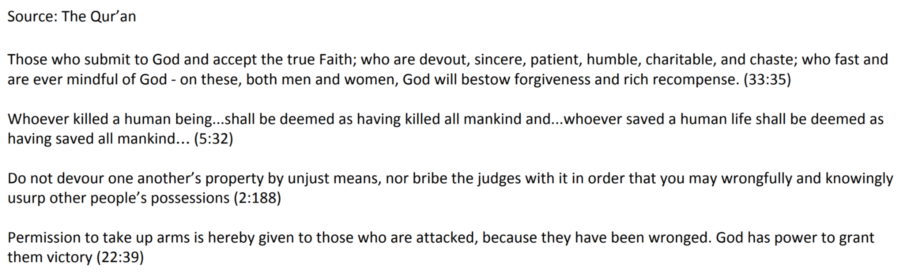
DOCUMENT 7:
How would you use this document to answer the prompt?
______________________________________________________________________________________________________________________________________________________________________________________________________________________________________________________________________________
DOCUMENT 8:

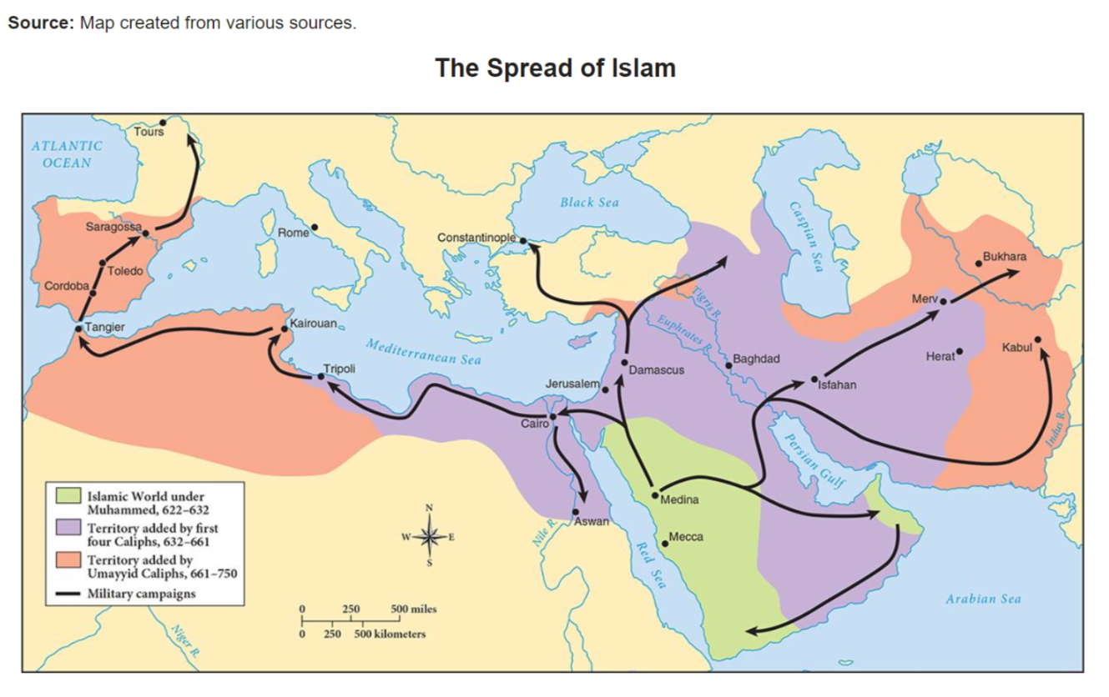
How would you use this document to answer the prompt?
______________________________________________________________________________________________________________________________________________________________________________________________________________________________________________________________________________

DOCUMENT 9:

Source: The Islamic capital of Cordoba was described by a contemporary (person alive at the time) as the “jewel of the world.” The Islamic schools and universities were preferred by European scholars such as Abelard and Roger Bacon. Philip Hitti describes Cordoba in Capital Cities of Arab Islam (University of Minnesota Press,1973).

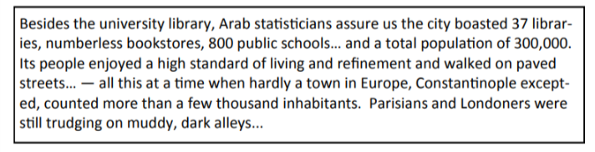

How would you use this document to answer the prompt?
______________________________________________________________________________________________________________________________________________________________________________________________________________________________________________________________________________

DOCUMENT 10:
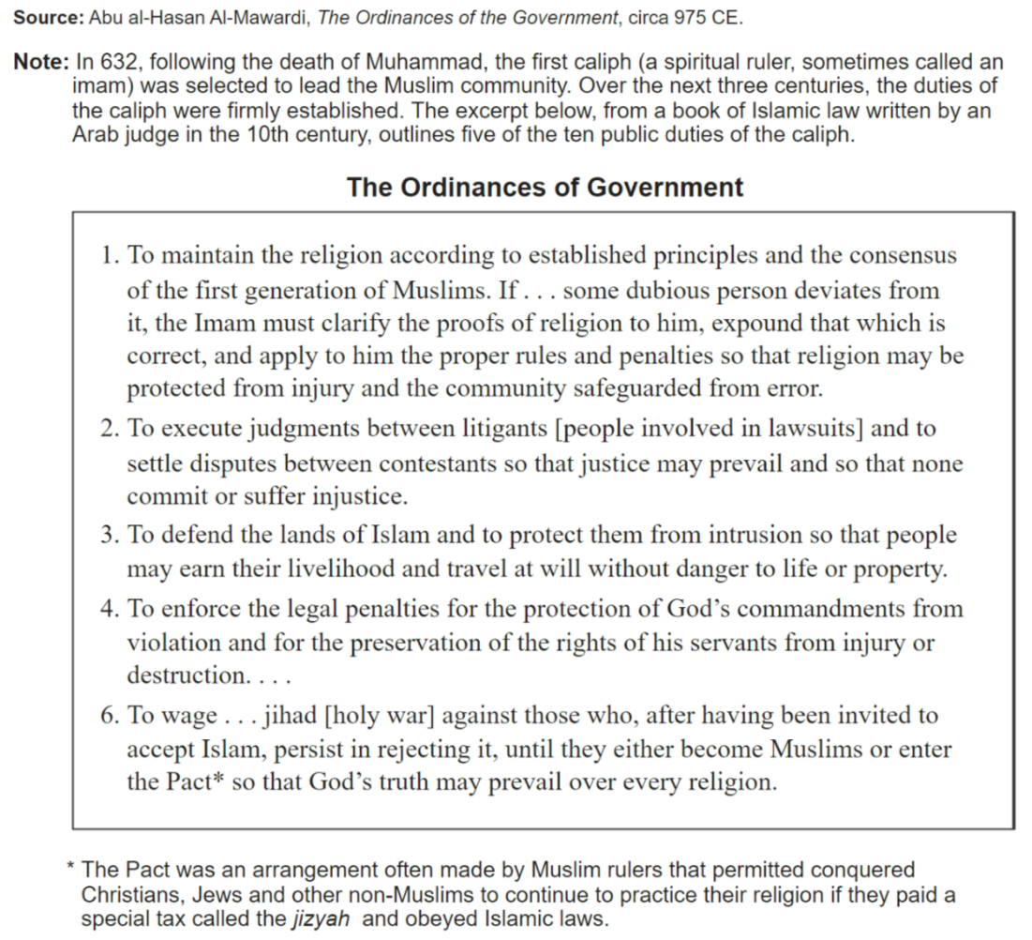

*A caliph is the political and religious leader of the Islamic empire – they control all aspects of politics and religion. (A way to think about it: if Pope Francis not only had control over the Catholic Church, but also over the government of Italy.)

How would you use this document to answer the prompt?
______________________________________________________________________________________________________________________________________________________________________________________________________________________________________________________________________________

“ANALYZE FACTORS THAT CONTRIBUTED TO THE SPREAD OF ISLAM” DBQ POSTER

- “What are we doing?” Read the green instruction sheet . If you’re still confused, here’s a summary:
  - We are examining factors that contributed to the spread of Islam
  - You will be doing this by analyzing documents, just as you would for a document-based question (DBQ)
  - Rather than writing a whole DBQ, you will be responsible for analyzing and organizing documents
    - Analyze each document. Tell me how it relates to the prompt. Organize the documents into thematic groups. Put everything onto a poster.
  - You also must write a historical context introduction and a thesis statement
  - See my poster for an example

- “What’s the prompt?” Read the background information! It’s in italics at the end of that! Or, read the top of this page

- “What’s a PIECES theme?” Political Characteristics, Innovation and Technology, Environmental Interactions, Cultural Characteristics, Economic Characteristics, and Social Structures. Use that hot pink sheet from the beginning of the year if you need help.
- “Do I have to use those themes?” Nope! But I like them because they’re general. If you want to get more specific and say “trade” instead of “economics,” you can!
- “But a lot of these can be in multiple categories” I know! It’s up to you to choose which category you think is best. There are multiple correct answers. It just depends on how you interpret the document.
- “How many groups do I need?” Documents must be grouped into at least three thematic groups. For something to be considered a group, it must have more than one document.
- “What else needs to be on the poster?” A historical context introduction and an analytical thesis statement.
  - Historical context introduction: This is like a “previously on…” clip before a new episode. What do I need to know to better understand what your thesis is? Situate your claim into the larger context of what’s happening in the world. See my example if you need help.
  - Thesis: it just needs to be analytical – tell me the how/why. But, feel free to use a counterclaim/counterargument. Look at the factors that contributed to the spread of Islam, and determine if one (or two) contributed more than the others.
    - Although X, Y, because A and B.
      - Although (this factor contributed a little for this reason), the factors that contributed the most to the spread of Islam were (this and this) because (of this reason) and (this reason).

- “Is there extra credit?” Yes, see the green sheet
- “What’s intended audience/perspective?” For one of the primary source documents, consider the author’s perspective or intended audience, and how that might impact what is being said and how it’s being said. This can be three or four sentences, and can be added anywhere next to the document.
  - Is the author a Muslim? Might that impact how he views the spread of his religion? What is his tone? Does that make him more or less trustworthy as a source?

- “When’s this due?” Woden’s Day at the beginning of class.
- “Is there a rubric?” Yep! Turn this page over!

