Adapted from Khan Academy

An Age of Adventure
Do you think that long-distance travel is a modern invention? Do you suppose that everyone stayed home until airlines started scheduling flights around the world?
If so, think again. By the early 1300s, Afro-Eurasia (Northern Africa, Europe, and Asia) had become a world zone in motion. People were traveling everywhere, usually in groups — by foot, donkey, horse, camel, and boat. Merchants moved goods; kings, sultans, and popes moved armies. Diplomats and envoys carried messages; missionaries sought souls. Pilgrims and scholars searched for enlightenment. People looked for work, and whole groups of people migrated for varying reasons. Captains, caravan leaders, travel guides, and transport experts provided the ways and means to keep the multitudes moving.
This long-distance travel became easier in the late 1200s and early 1300s largely for three reasons: First, nomads of Central Asia (the Mongols and their Turkish-speaking allies) conquered Russia, China, and most of the Middle East, creating the largest territorial empire the world had ever seen. Their rulers imposed order and security to the trade routes along the Silk Roads. Second, the stability of Islamic rule across North Africa, the Middle East, Persia, and Southeast Asia provided a common civilization for travelers. Third, improvements in sailing technologies increased sea travel in the Indian Ocean.
Considering the great numbers of travelers moving across Afro-Eurasia, very few individuals left written accounts of their journeys. We’re left to believe that those who did record their travels must also represent the unknown adventurers who left no accounts.

Fortunately, two prodigious travelers, Marco Polo, of Venice, Italy, and Abu Ibn Battuta, of Tangier, Morocco, did leave engaging records of their journeys. They each told their stories from memory, and perhaps some written notes, to others who copied it down. Enough copies were made that some have survived through the centuries. A third traveler featured here, Zheng He, from Yunnan, China, is remembered because he served powerful Chinese emperors. He left brief accounts of his voyages carved in granite, and two officers and a translator who sailed with him left longer memoirs.
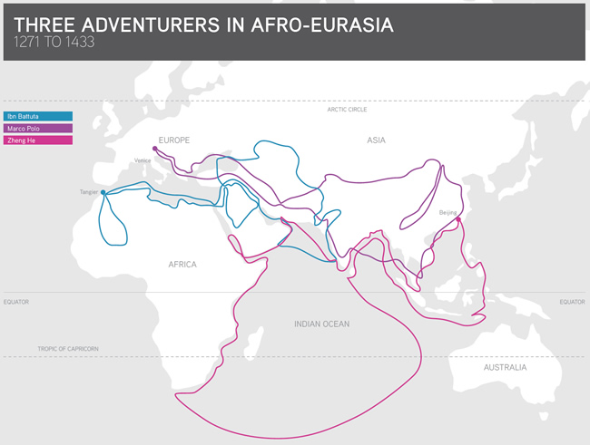
These three adventurers all traveled within a 162-year time period. Marco Polo started his journey in 1271; Ibn Battuta started his in 1325, just after Polo died. Zheng He made his seven voyages starting in 1403, 37 years after Ibn Battuta died.
The extent of these three journeys defies our imagination, even today in the age of jet travel around the world. Marco Polo spent 24 years away from home, traveling most of the time. Ibn Battuta spent 29 years away, visiting the lands of more than 40 modern countries, and covering 73,000 miles (117,000 kilometers). Zheng He was away about 14 years spaced over three decades, making his way around the Indian Ocean and along the eastern coast of Africa.

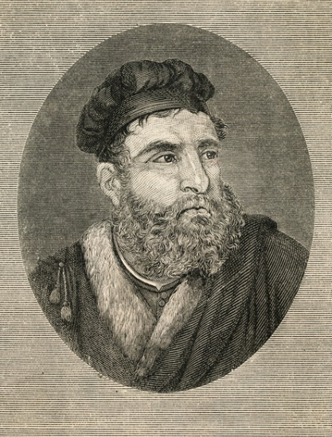
Italian Trader at the Court of Kublai Khan
At the height of the Mongol Empire, Marco Polo served Emperor Kublai Khan in China and returned to Venice to write an account of his experiences that would give Europeans some of their earliest information about China.

In the 13th century, people who lived in Venice, Italy, believed that the Sun revolved around the Earth and that creation occurred exactly 4,484 years before Rome was founded. As Christians, they considered Jerusalem, the place of Jesus’s crucifixion, to be the so-called ‘navel of the world,’ and their maps portrayed this.
Marco Polo was born in Venice in 1254. Located on the eastern coast of Italy, Venice served as a gateway to the riches of Asia during this era of increasing trade. Goods flowed like water through the city. Ships from around the eastern Mediterranean docked at its port. Merchants and traders set sail from Venice for Constantinople (now Istanbul) and the Black Sea to fetch goods from Russia and from merchants who traveled the Silk Roads, a system of trading routes to and from China that crossed the mountains and deserts of Central Asia.
At the time of Marco’s birth, his father, Niccolo, and two uncles, all merchants, were away trading. Supposedly they were visiting cities on the Black Sea, but their adventures had actually taken them all the way to the Mongol capital of China, Khanbaliq (city of the Khan). There they had an audience with the most powerful ruler of the day, Kublai Khan, grandson of the founding emperor, Genghis Khan. When the three Polo men returned to Venice after an absence of 16 years, Niccolo found that his wife had died and that he had a 15-year-old son, Marco, whom he did not know existed.

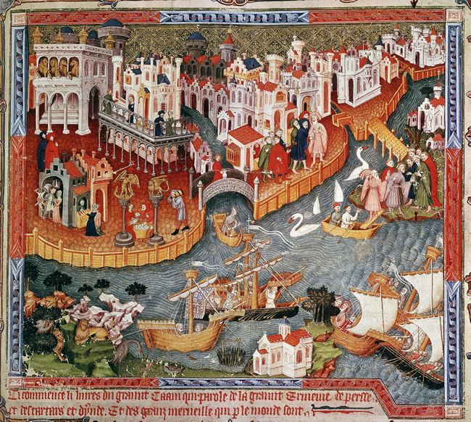
Two years later, in 1271, Niccolo Polo and his brother, Maffeo, set off again, taking the 17-year-old Marco with them. This time they aimed directly for the court of Kublai Khan, to bring him documents from the pope and holy oil from Jerusalem that he had requested. Even with a gold passport from Kublai Khan, which enabled the travelers to use lodgings and horses posted by the Mongols along the Silk Road routes, they took three and a half years to arrive. Upon reaching the summer palace of Kublai Khan in 1275, Niccolo presented his son and offered him in service to the emperor.

A talented young man, Marco had learned several languages along the way, including Mongolian (though not Chinese), and had mastered four written alphabets. Two years before Marco’s arrival, Kublai Khan had completed the conquest of all parts of China and needed non-Mongol administrators in areas that resisted having Mongol authorities. Marco took on various sorts of diplomatic and administrative roles for the emperor from his base in Dadu, which Kublai Khan built next to Khanbaliq. Both Dadu and Khanbaliq stood at what is now Beijing. After more than 16 years in China, the Polos begged permission from Kublai Khan to return home to Venice. Apparently they had proved so useful to the khan that he did not want them to leave. Finally, he agreed for them to escort a Mongolian princess, Cogatin, to become the bride of a Persian khan; thus they headed back west.
This time they traveled by sea in Chinese ships and, after many difficulties, succeeded in delivering the princess. Before they could reach Venice, however, Kublai Khan died on February 18, 1294, which allowed local rulers to reassert themselves and demand payment from traders. Consequently, the Polos were forced to hand over 4,000 Byzantine coins, a significant portion of their fortune, to the local government of a city on the Black Sea.
The Polos returned to Venice in 1295, having been away 24 years. Their enthusiastic biographer told stories, which may have been gossip, that when they returned they were wearing Mongolian clothing and could hardly remember their native language. Their relatives had thought them long dead. But when they produced a small fortune in gems (rubies, sapphires, garnets, diamonds, and emeralds), which had been sewn into the hems of their Mongolian garments, they were warmly welcomed.
Soon Venice was at war with its rival city-state, Genoa, on the west coast of Italy. As was custom for a wealthy merchant, Marco Polo financed his own war galley. He was captured during a naval battle and ended up in prison in Genoa.
By chance, one of his cellmates, Rusticello from Pisa, had experience writing romantic novels. As Polo entertained everyone with his tales of traveling to China, Rusticello wrote them down in a French dialect. This is how Polo’s accounts, Europe’s primary source of information about China until the 19th century, came into existence.
In 1299 Genoa and Venice declared peace; Polo was released and returned to Venice to marry Donata Badoer. The couple had three daughters in quick succession. He spent his remaining days as a businessman, working from home. He died there at almost 70 years of age, on January 8, 1324, and was buried under the church of San Lorenzo, though his tomb has now vanished.

Polo might have been forgotten had his book, The Travels of Marco Polo, not engaged widespread interest. It could be circulated only one copy at a time, since printing in Europe did not begin until almost 200 years later. About 120 to 140 early manuscripts — hand-printed and fragmentary versions of The Travels — survive, and every one of them is different. The earliest readers were scholars, monks, and noblemen. Soon translations of The Travels appeared, in Venetian, German, English, Catalan, Argonese, Gaelic, and Latin. It took more than a century for the book to become part of mainstream European consciousness.
Few texts have provoked more controversy than The Travels of Marco Polo. The authorship is not clear — is it Polo or Rusticello? Sometimes the text is in the first-person voice, sometimes in the third-person. How much of the text is based on Polo’s firsthand experience and how much did the author(s) insert secondhand accounts by others? Certainly it’s a mix. What was reported seemed so bizarre to stay-at-home Europeans that the readers often assumed that everything was made up. Yet historians have largely confirmed the facts in Polo’s account of the height of the Mongol dynasty.
Polo proved an engaging storyteller. He found Mongolian customs fascinating and reported them enthusiastically, such as the use of paper for money and the burning of coal for heat (see excerpts below). Paper money had been utilized in China for several hundred years, and coal had been burned in parts of China since the beginning of agriculture.
Polo also missed a few unfamiliar practices, notably the books being sold in Quinsa (now Hangzhou), the capital city of the earlier Song dynasty in southern China. Books were widely available there because they were printed with moveable type made of wood, clay, or tin. Moveable type was missing in Europe until 1440, when Johannes Gutenberg, a German printer, invented it there.
When Christopher Columbus set sail on August 3, 1492, hoping to find a route by sea to China, he carried with him a heavily annotated copy of The Travels of Marco Polo, expecting it to be useful.
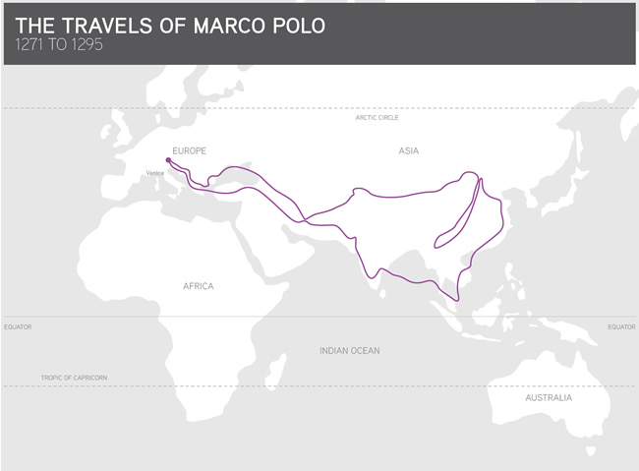
After you read, answer the following questions:
- What world zones did Marco Polo connect?
- What was the motivation for his exploration? Think PIECES themes.
- What did he discover? Land, people, goods, ideas, or a combination of these?
- How did he contribute to collective learning? Focus on things such as ideas, goods, technology, religion, and politics
- What were the effects of Il Milione?

